GUJARAT TECHNOLOGICAL UNIVERSITY

Chandkheda, Ahmedabad

Affiliated

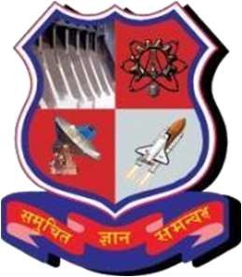 

NEW LJ INSTITUTE OF ENGINEERING AND TECHNOLOGY

A

Project Report

On

**Detection of Drowsiness in Drivers**

Under subject of

DESIGN ENGINEERING – 2B

B.E, Semester – VI

CSE (AI/ML)

Submitted by: Bug Busters

Group: 11

|  |  |  |
| --- | --- | --- |
| **Sr.** | **Name** | **Enrollment No.** |
| 1 | Yanshu Patel | 201430142022 |
| 2 | Hetvi Mudra | 201430142073 |
| 3 | Vatsal Bhimani | 201430142019 |

**Prof. Prakruti Parmar**

(Internal Guide)

**Dr. Gayatri Pandi**

(Head of the department)

**Academic Year**

(2022-2023)

CERTIFICATE

This is to certify that project work embodied in this report entitled “Detection of Drowsiness in Drivers” was carried out by below mentioned students at department of CSE (AIML), NEW L J Institute of Engineering and Technology, Ahmedabad for partial fulfilment of the subject design engineering 2B. This project work has been carried out under my supervision and is to the satisfaction of department.

|  |  |  |
| --- | --- | --- |
| Sr. | Name of Student | Enrollment No. |
| 1. | Yanshu Patel | 201430142022 |
| 2. | Hetvi Gaurav Mudra | 201430142073 |
| 3. | Bhimani Vatsalkumar Arvindkumar | 201430142019 |

INTERNAL

GUIDE SIGN HOD SIGN COLLEGE SEAL

ACKNOWLEDGEMENT

I cannot express enough thanks to my support members for their continued support and encouragement: Ms. Gayatri Pandi (HOD), Prof. Prakruti Parmar (Guide). I offer my sincere appreciation for the learning opportunities to my support members.

The completion of this project could not have been accomplished without the support of the team members. A special thanks goes to my team members they help me to assemble the parts and gave suggestion about the project.

Besides, we would like to thank all the teachers who helped us by giving us advice and providing the material required. I would like to thank my family and friends for their support. Without that support we couldn’t have succeeded in completing this project. At the end, we would like to thank everyone who helped and motivated us to work on this project.

ABSTRACT

The major aim of this project is to develop a drowsiness detection system by monitoring the eyes; it is believed that the symptoms of driver fatigue can be detected early enough to avoid a car accident. In such a case when drowsiness is detected, a warning signal is issued to alert the driver.

This detection system provides a noncontact technique for judging different levels of driver alertness and facilitates early detection of a decline in alertness during driving. In such a case when fatigue is detected, a warning signal is issued to alert the driver. The system also has additional feature of slowing down the vehicle if driver fails to respond to the alarm and ultimately stops the vehicle.

LIST OF FIGURES

Figure 1. Snapshot 1 10

Figure 3. layout Of App ...................................................................................................12 12

Figure 4. AEIOUS Canvas 18

Figure 5. Mind Map Canvas 19

Figure 6. Emapathy Canvas 21

Figure 7. Ideation Canvas 22

Figure 8. Prototype Model 23

Figure 10. Learning Need Matrix Canvas 26

LIST OF ABBREVIATIONS

|  |  |
| --- | --- |
| AEIOUS | Activities, Environment, Interaction, Objects, User |
| GPS | Global Positioning System |
| GIS | Geographical Information System |
| ISO | International Organization for Standardization |
| IEC | International Electrotechnical Commission |

INDEX

|  |  |  |
| --- | --- | --- |
| Sr. No. | Topic | Page No. |
| 1 | Introduction 1.1  Phase 1. ReverseEngineering(RE) : Selection and disassembling of art fact/component Phase 2. : Disassembly / Analysis of the component / product / art fact / program and learning about the topic | 9 |
|  | Project Summary 1.2 | 10 |

|  |  |  |
| --- | --- | --- |
| 2 | Introduction 2.1 | 11 |

|  |  |  |
| --- | --- | --- |
|  | Project Summary 2.2 | 12 |
| 3 | AEIOU Canvas | 15 |
| 4 | Mind Map Canvas | 17 |
| 5 | Empathy Canvas | 18 |
| 6 | Ideation Canvas | 20 |
| 7 | Prototype | 21 |
| 8 | Product Development Canvas | 22 |
| 9 | Learning Need Matrix Canvas | 23 |
| 10 | Feedback Analysis | 24 |
| 11 | Conclusion | 25 |
| 12 | References | 26 |

Introduction 1.1

Phase 1: Reverse Engineering (RE): Selection and disassembling of art fact /component.

# Figure 1. Snapshot 1

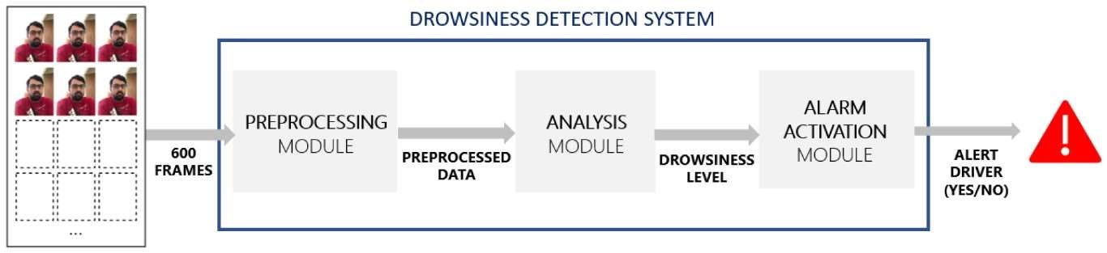

Phase 2: Disassembly / Analysis of the component / product / art fact / program and learning about the topic

1. List of Observed features:

* + Map: A map through which users can see the location of car

* + Camera: users can capture live pictures of person.

* + Alarm: to wake up the driver

The system uses a small infra-red night vision camera that points directly towards the driver's face and monitors the driver's eyes in order to detect fatigue. In such a case when fatigue is detected, a warning signal is issued to alert the drive

This application can be used by:-

Drowsiness detection is a safety technology that can prevent accidents that are caused by drivers who fell asleep while driving.

# Figure 3. Layout Of App

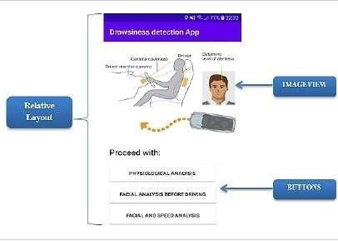

Project Summary 1.2

|  |  |  |  |  |  |  |  |  |  |  |  |  |  |
| --- | --- | --- | --- | --- | --- | --- | --- | --- | --- | --- | --- | --- | --- |
| Sr. No | Paper Title | | | | Paper Author | | | | | | | Published  Year | Summary |
| 1. |  | Imagenet |  | |  | Krizhevsky, A., | | | | |  | 2012 | We trained a large, deep convolutional neural network to classify the 1.2 million high- resolution images in the ImageNet  LSVRC-2010 contest into the 1000 different classes. On  the test data, we achieved top-1 and top-5 error rates of 37.5% and  17.0%, respectively, which is considerably better than the previous state-of-the-art. he neural network, which has 60 million parameters and 650,000 neurons, consists of five convolutional layers, some of which are followed by maxpooling layers. |
| classification | |  | Sutskever, I., | | | |  |
| with deep convolutional neural networks. In:  NIPS, pp.  1097–1105  (2012) | | Hinton, G.E. | | |  |
|  | | |
| 2. | Deep face recognition.   |  |  | | --- | --- | | In: BMVC, vol. | | | 1, p. 6 |  | | | | |  | Parkhi, O.M. | | | | , | | 2015 | Mastering the laws of wildlife activities and family territory is an important task for wildlife protection, habitat restoration, and epidemic surveillance. Aiming at the shortcomings of traditional wildlife monitoring methods, an overall framework of wild animal satellite tracking system is proposed, and key technologies such as MEMS design, wearable methods, and big data platform development are discussed and practiced. |
| Vedaldi, A., | |  | |
| Zisserma |  |
|  |

Introduction 2.1

Designing means involving goal-oriented processes. At the beginning of the design process only goals are known while at the end, both the goals and plans are known and that to with more clarity. Goal and plans involve together and they influencing each other. In designing process some goals are more important than others and similarly some plans are better than others. Designing does not guarantee that the design will work. Design thinking process:

* As per our subject in Gujarat Technology University we have a subject name Design Engineering.
* Design thinking is the cognitive process from which concepts emerge.
* Design thinking is related to, but different from problem solving, decision making, making creativity, sketching and prototyping.
* During Design thinking, the designer’s attention oscillates between their understanding of a problematic context and their ideas for a solution.
* We have to find our area or field in which we want to do our project.
* We have observed that in this time Patients can’t get proper health care. So, we came with the solution by the help of data mining system.

Project Summary 2.2

This work presents the development of an ADAS (advanced driving assistance system) focused on driver drowsiness detection, whose objective is to alert drivers of their drowsy state to avoid road traffic accidents. In a driving environment, it is necessary that fatigue detection is performed in a non-intrusive way, and that the driver is not bothered with alarms when he or she is not drowsy. Our approach to this open problem uses sequences of images that are 60 s long and are recorded in such a way that the subject’s face is visible. To detect whether the driver shows symptoms of drowsiness or not, two alternative solutions are developed, focusing on the minimization of false positives. The first alternative uses a recurrent and convolutional neural network, while the second one uses deep learning techniques to extract numeric features from images, which are introduced into a fuzzy logic-based system afterwards. The accuracy obtained by both systems is similar: around 65% accuracy over training data, and 60% accuracy on test data. However, the fuzzy logic-based system stands out because it avoids raising false alarms and reaches a specificity (proportion of videos in which the driver is not drowsy that are correctly classified) of 93%. Although the obtained results do not achieve very satisfactory rates, the proposals presented in this work are promising and can be considered a solid baseline for future works.

**AEIOU Canvas**

AEIOU is an investigative tool to help interpret observations gathered by ethnographic practices in the field. It is an Observations tool. AEIOU stands for 5 elements to be coded: Activity, Environment, Interaction, Object and User.

1. Environment:

* Highways
* Sideways

1. Interaction:

* Human-camera
* Argos satellite

3.Objects:

* Satellite
* Phones
* Sensors
* Cameras

4. Activities:

* Safety of humans
* Save human lives

5. Users:

* Car-drivers
* Truck-drivers

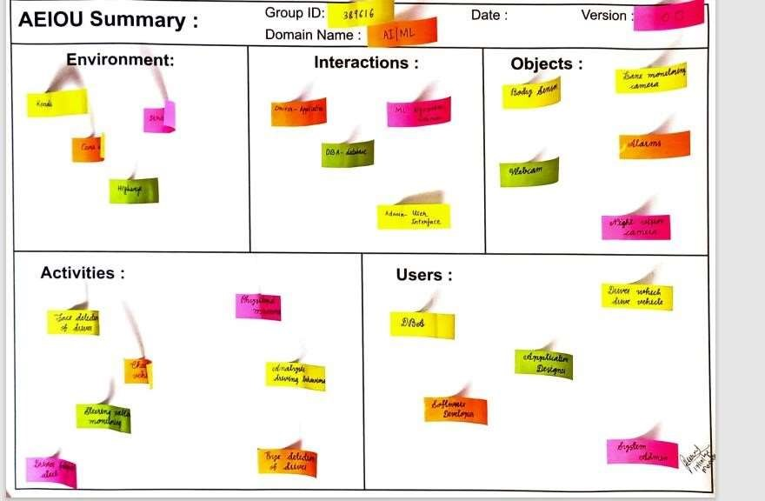

# Figure 4. AEIOUS Canvas

**Mind Map Canvas**

Mind mapping was developed as an effective method for generating ideas by association. Mind mapping can be used for generating, visualizing, organizing, note-taking, problem-solving, decision-making, revising and clarifying your university topic, so that you can get started with assessment tasks. Essentially, a mind map is used to ‘brainstorm’ a topic and is a great strategy for students.

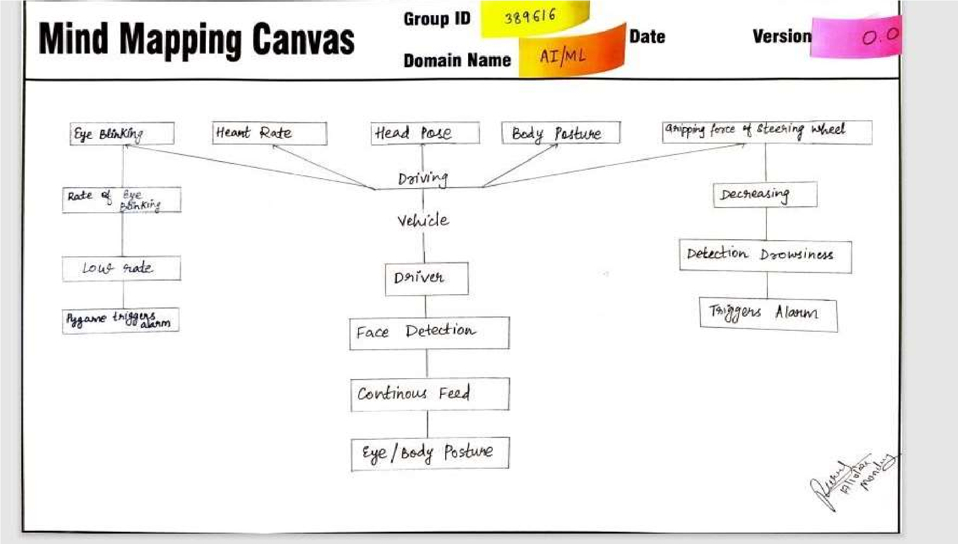

# Figure 5. Mind Map Canvas

**EmpathyCanvas**

Understanding the society is one of the biggest challenges for engineering students as till now they were making project on imaginary ideas. Understanding the domains of the problem in broader sense which emphasized on interacting with the people of your domain area which included more of casual talk rather than technical session. Here we would like to explain the aspects of this canvas with the help of the example taken up by our team.

1. Users:

○ DBA

○ Drivers

○ System Admin

○ Stakeholders

1. Stack holder:

○ Application designer

○ Software Developers

○ Technical Engineers

○ Data Operators

1. Activities:

○ Face detection

○ Eye detection

○ Detecting level of drowsiness

○ Real-time location monitoring

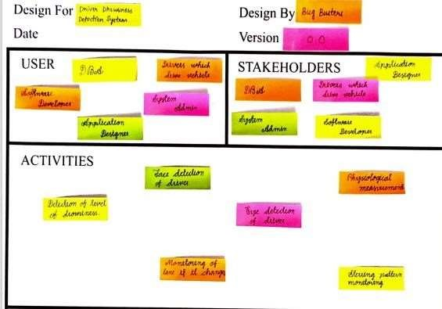

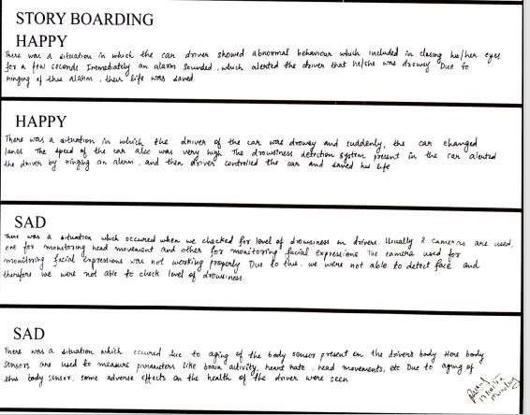

Figure 6. Empathy Canvas

**Ideation Canvas**

A range of ideation techniques can be used to generate ideas and solutions, including sketching, prototyping, brainstorming, brain writing, worst possible ideas, and many others. A design process that focuses on generating ideas is called ideation.

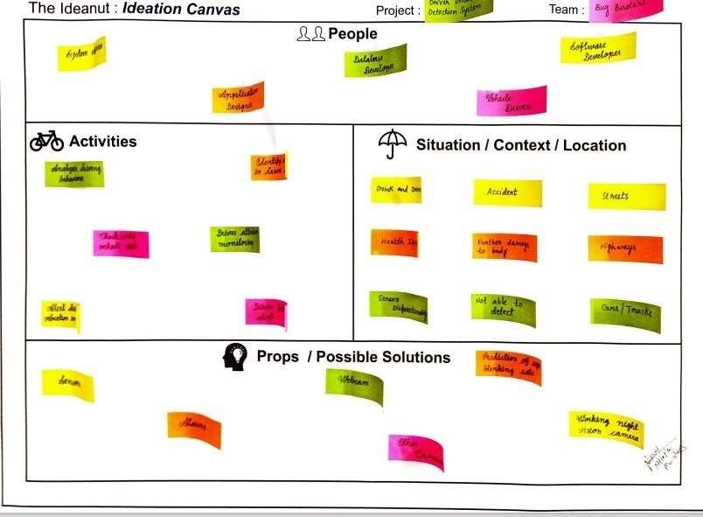

# Figure 7. Ideation Canvas

**Rough Prototype Model**

Prototyping is often presented as a universal solution to many intractable information systems project problems.

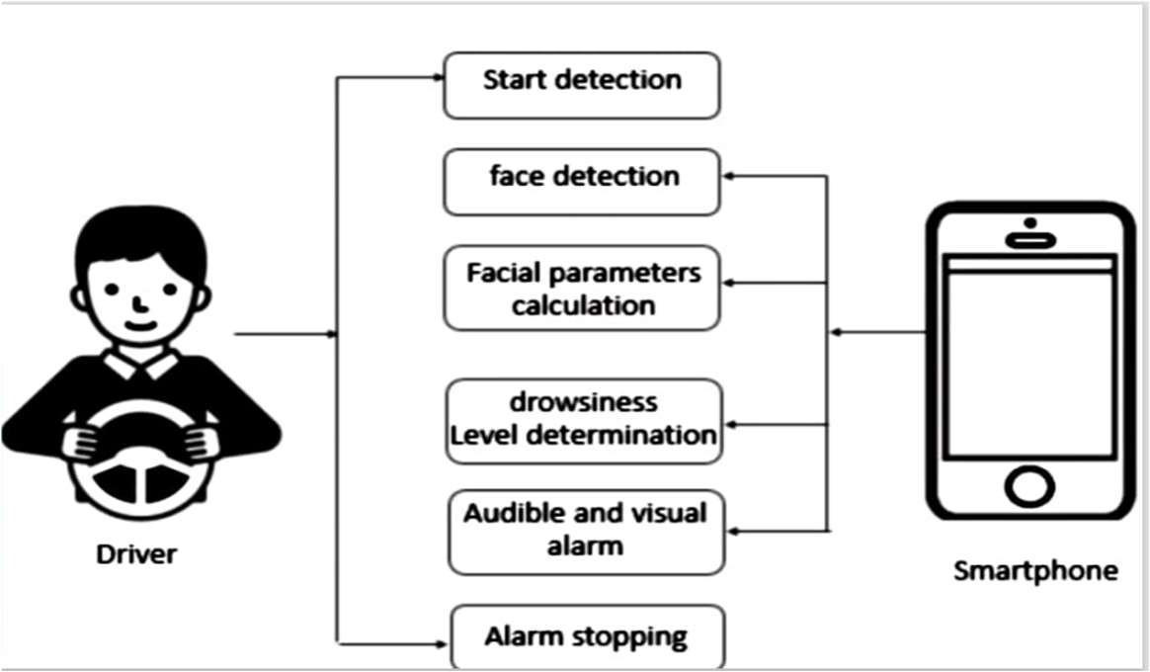

# Figure 8. Prototype Model

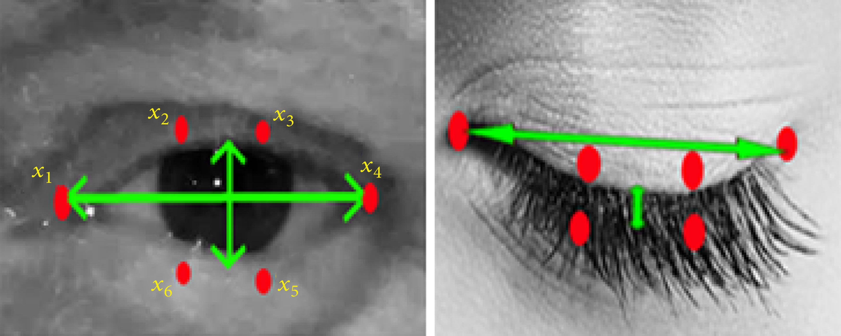

**Product Development Canvas**

A product canvas is a planning tool designed to help build products that have a great user experience through a focus on feature development.

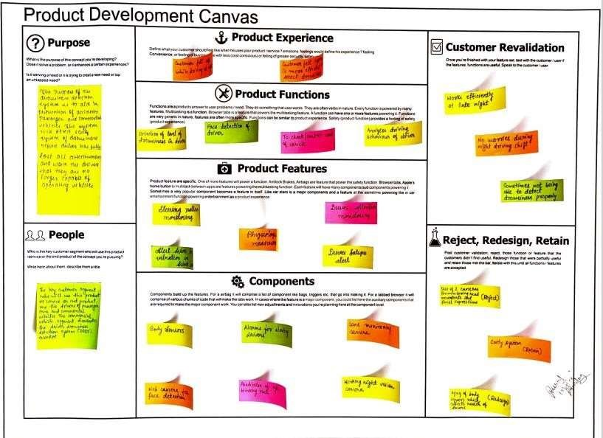

Figure 9. Product Development Canvas

1. Tools/Methods/Theory/Application Process

○ Face detection

○ Eye detection

1. Applicable standards and design specification/ Principles & experiments

○ ISO

○ IEC

1. Software/Simulation/Skill/Mathematical Requirement

○ Pygame, Open CV

1. Component materials strength(exploration – varieties/testing requirements)

○ Camera, webcam

**Learning Needs Matrix**

First of all LNM canvas (LN Matrix) full form is the Learning Needs Matrix Canvas will help the student to identify the learning requirement at an early stage along with prioritization/time allocation for each learning priority.

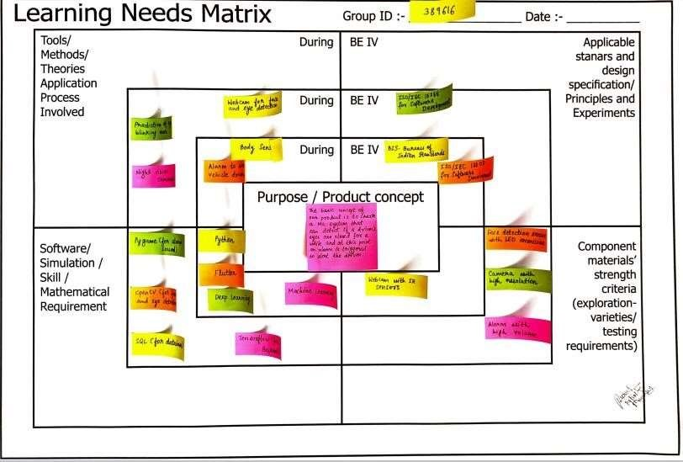

# Figure 10. Learning Need Matrix Canvas

**Feedback Analysis**

Our team went on field work, to check whether the application is working or not as the system requires a good internet access.

The certain problem they were facing were:

* Lack of road data
* Inconsistent protocols for data collection
* Subjective and incoherent labelling of drowsiness
* Aging of sensors used in system
* Using two cameras, one for monitoring head movement and another for facial expression

The different feedback and the views they gave for Detection of Drowsiness in Drivers are:

* It detects abnormal behaviour and rings an alarm
* It has established interface with other drivers
* Speed of vehicle can be controlled
* Major accidents can be prevented

**Conclusion**

The aim of this work was to design and implement a user-friendly driver monitoring and drowsiness detection application however, aimed at providing ease of use, availability, reduced cost and privacy since data was stored in the user phone before and while driving. The driver could be tested for drowsiness even before driving.

**References**

1. T. Covington, Thezebra.com, 2020.

URL https://www.thezebra.com/drowsy-driving-statistics/.

1. J. M. Owens, T. A. Dingus, F. Guo, Y. Fang, M. Perez, J. McClafferty and B. Tefft. Prevalence of drowsy-driving crashes: Estimates from a large-scale naturalistic driving study. Research Brief, AAA

Foundation for Traffic Safety, Washington, DC, February 2018.

1. Drowsy driving. URL https://www.nsc.org/road-

safety/safetyhttps://www.nsc.org/road-safety/safety-topics/fatigued-drivingtopics/fatigueddriving, 2020.

1. Facts about drowsy driving. URL

https://drowsydriving.org/wphttps://drowsydriving.org/wp-content/uploads/2009/10/DDPWDrowsy-Driving-Facts.pdfcontent/uploads/2009/10/DDPW-Drowsy-DrivingFacts.pdf, 2020.

